Seastar Dissection Quiz

- Name the following parts of the Seastar.

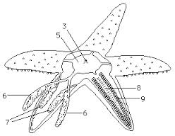

1.
2.
3.
4.
5.
6.
7.
8
9.

