**Physics 1:**

**Forces & Motion**

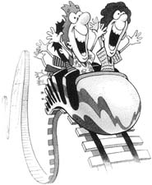

**Medler - 106**

Website: www.cmedler.weebly.com

Email: cmedler@alpinedistrict.org

Name: ___________________________________________ Period: ___________

|  |  |
| --- | --- |
| **Lab Activities** |  |
| Starter Questions |  |
|  |  |
| Vocabulary |  |
| Day 1: Velocity & Motion PPT |  |
| Lab: Velocity & Motion |  |
| Day 2: Acceleration PPT |  |
| Lab: Marble Madness |  |
| Day 3: Forces PPT |  |
| Inertia Demo |  |
| Lab: Forces & Inertia (I) Create a Lab |  |
| Day 4: Unbalanced Forces PPT |  |
| Lab: Forces & Inertia (II) |  |
| Total: |  |

**Starter Questions:**

|  |
| --- |
| Day 1 |
| Day 2 |
| Day 3 |
| Day 4    **/ .** |
| Day 5 |
| Day 6 |

**Unit Vocabulary:** (Use a dictionary or science textbook to complete the words below)

**/10**

1. **Word: Velocity**
   1. Definition:_____________________________________________________________________**__________________________________________________________________________________________**
   2. Formula:
2. **Word: Acceleration**
   1. Definition:_______________________________________________________________________________________________________________________________________________________________
   2. Formula:
3. **Word: Force**
   1. Definition:_______________________________________________________________________________________________________________________________________________________________
   2. Formula:
4. **Word: Terminal Velocity**
   1. Definition:_______________________________________________________________________________________________________________________________________________________________
5. **Word: Inertia**
   1. Definition:_______________________________________________________________________________________________________________________________________________________________
6. **Word: Mass**
   1. Definition:_______________________________________________________________________________________________________________________________________________________________
7. **Word: Friction**
   1. Definition:_______________________________________________________________________________________________________________________________________________________________

*/14*

**Total**:

/60

1. ***Question:*** *From your OBSERVATION… How do we know if something’s moving?*
2. ***Question****: How would you determine if something is moving fast or moving slow?*
3. ***Question:*** *What variables would you need to consider using to determine that an object is in motion?*
4. ***Question:*** *How would you set up an experiment to determine if an object is moving fast or slow?*
5. ***Question****: If you used a line graph, how would you set it up?*
6. ***Question****: How does the number of batteries in an electric car affect the speed of the car?*
7. ***Prediction****: Based on your hypothesis (your answer to a scientific question) predict what you think the graph would look like for a fast and slow moving object on a distance v. time graph.*

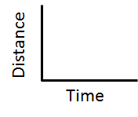

***Create-a-Lab:* /**10

1. *Next, discuss how you would test your answer/hypothesis using the equipment provided in class.*
   1. *Consider what variables you need to keep the same. ______________________________ (Cont)*
   2. *Consider what variable you want to change. ______________________________ (Ind)*
   3. *Consider what variable you need to measure. ______________________________ (Dep)*
2. *Write up your lab procedures to test your hypothesis in the space provided below (4):*

*Next collect and analyze your data to see if it either proves or disproves your hypothesis.*

**Question:** *How does the number of batteries affect the speed of a toy car?*

**Hypothesis:**

**Materials:**

* Masking Tape
* Timer
* Meter Stick
* Calculator
* Toy Car

**Part I**: 2 Toy Cars /6 (2: Title, 2 Headers, Data)

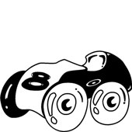Use the data tables below as a resource for you to organize your data.

Determine the dependent and independent variables.

**Car Name**: _______________

|  |  |
| --- | --- |
| ***Title of Data Table: (2)*** | |
|  |  |
|  |  |
|  |  |
|  |  |
|  |  |
|  |  |
|  |  |

**Car Name**: _______________ /6 (2: Title, 2 Headers, Data)

|  |  |
| --- | --- |
| ***Title of Data Table: (2)*** | |
|  |  |
|  |  |
|  |  |
|  |  |
|  |  |
|  |  |
|  |  |

**Graphing Exercise:** /12 (2pts ea. line, dots, scale, legend)

In the graph below, label the axis based on the independent and dependent variables, set up your scale and plot your results of your two cars. Finally, take a straight edge and draw a line that best fits your data.

*If I may, I would suggest you use different colors to represent the two cars. Create a legend to label each line that is graphed.

|  |  |  |  |  |  |  |  |  |  |  |  |  |  |  |  |  |  |  |  |  |  |  |  |  |
| --- | --- | --- | --- | --- | --- | --- | --- | --- | --- | --- | --- | --- | --- | --- | --- | --- | --- | --- | --- | --- | --- | --- | --- | --- |
| **Title:** | | | | | | | | | | | | | | | | | | | | | | | | |
|  |  |  |  |  |  |  |  |  |  |  |  |  |  |  |  |  |  |  |  |  |  |  |  |  |
|  |  |  |  |  |  |  |  |  |  |  |  |  |  |  |  |  |  |  |  |  |  |  |
|  |  |  |  |  |  |  |  |  |  |  |  |  |  |  |  |  |  |  |  |  |  |  |
|  |  |  |  |  |  |  |  |  |  |  |  |  |  |  |  |  |  |  |  |  |  |  |
|  |  |  |  |  |  |  |  |  |  |  |  |  |  |  |  |  |  |  |  |  |  |  |
|  |  |  |  |  |  |  |  |  |  |  |  |  |  |  |  |  |  |  |  |  |  |  |
|  |  |  |  |  |  |  |  |  |  |  |  |  |  |  |  |  |  |  |  |  |  |  |
|  |  |  |  |  |  |  |  |  |  |  |  |  |  |  |  |  |  |  |  |  |  |  |
|  |  |  |  |  |  |  |  |  |  |  |  |  |  |  |  |  |  |  |  |  |  |  |
|  |  |  |  |  |  |  |  |  |  |  |  |  |  |  |  |  |  |  |  |  |  |  |
|  |  |  |  |  |  |  |  |  |  |  |  |  |  |  |  |  |  |  |  |  |  |  |
|  |  |  |  |  |  |  |  |  |  |  |  |  |  |  |  |  |  |  |  |  |  |  |
|  |  |  |  |  |  |  |  |  |  |  |  |  |  |  |  |  |  |  |  |  |  |  |
|  |  |  |  |  |  |  |  |  |  |  |  |  |  |  |  |  |  |  |  |  |  |  |
|  | | | | | | | | | | | | | | | | | | | | | | | |
|  |  | | | | | | | | | | | | | | | | | | | | | | | |

**Line Legend/Key**

|  |  |
| --- | --- |
| **Line** | **What does each color line mean or represent** |
|  | **Slow** |
|  | **Fast** |

**Data Analysis Questions: /18**

1. How can you tell if something’s moving fast?
2. How can you tell if something’s moving slow?
3. Based on the previous questions and this lab; how would you calculate for speed? (In other words, what is speed equal to?)
4. Based on your inference statements, circle the phrase in the sentence that best fits your observations from the data you collected:
   1. The faster the object, the slope (Rises High / Rises Low). The slower the object, the slope (Rises High / Rises Low).
5. Based on your data and graph, identify which line is the fastest.

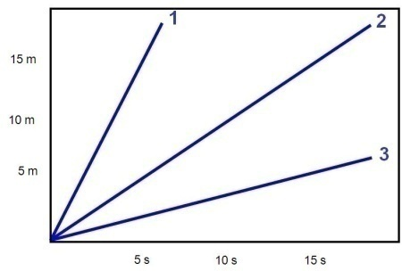

1. Based on your findings, draw a line graph and estimate what it would look like if a car started slow for 4 seconds, stopped for 2 seconds and then went fast for 5 more seconds. (1pts scale, 1 pt ea. For axis labels, 1 pt for title, 3pts line)

|  |  |  |  |  |  |  |  |  |  |  |  |  |
| --- | --- | --- | --- | --- | --- | --- | --- | --- | --- | --- | --- | --- |
|  |  |  |  |  |  |  |  |  |  |  |  |  |
|  |  |  |  |  |  |  |  |  |  |  |  |  |
|  |  |  |  |  |  |  |  |  |  |  |  |  |
|  |  |  |  |  |  |  |  |  |  |  |  |  |
|  |  |  |  |  |  |  |  |  |  |  |  |  |
|  |  |  |  |  |  |  |  |  |  |  |  |  |
|  |  |  |  |  |  |  |  |  |  |  |  |  |
|  |  |  |  |  |  |  |  |  |  |  |  |  |
|  |  |  |  |  |  |  |  |  |  |  |  |  |
|  |  |  |  |  |  |  |  |  |  |  |  |  |

**Conclusion**: Use your data that you collected to answer the original question: *How does the number of batteries in an electric car affect the speed of the car?*

**Total**:

/40

**Question:** How does the angle of a ramp affect the velocity of a marble?

**Hypothesis(2):**

**Materials**:

* Marble Tracks
* Steel Balls
* Ruler
* Calculator
* Ticker Tape
* 3 Text Books
* Colored Pens & Pencils
* Timer

**Part I**: Distance Evaluation of Acceleration

**Procedures(4):**

**Pre Lab Questions:** /3

1. What is the independent variable in this lab? ________________________________
2. What is the dependent variable in this lab? ________________________________
3. What is the controlled variable in this lab? ________________________________

/10

|  |  |  |  |  |  |  |  |  |  |  |  |  |
| --- | --- | --- | --- | --- | --- | --- | --- | --- | --- | --- | --- | --- |
|  | | | | | | | | | | | | |
|  |  |  |  |  |  |  |  |  |  |  |  |  |
|  |  |  |  |  |  |  |  |  |  |  |  |  |
|  |  |  |  |  |  |  |  |  |  |  |  |  |
|  |  |  |  |  |  |  |  |  |  |  |  |  |

**Part II**: Graphing

By using different colors to represent the three different trials, create a legend, and then create the following graphs from the data you collected: Dist. v. Time. (2pts/line = 6pts)

Marble velocity at different ramp angles, Distance v. Time

|  |  |  |  |  |  |  |  |  |  |  |  |  |  |  |  |  |  |  |  |  |  |
| --- | --- | --- | --- | --- | --- | --- | --- | --- | --- | --- | --- | --- | --- | --- | --- | --- | --- | --- | --- | --- | --- |
| [cm]  Distance |  |  |  |  |  |  |  |  |  |  |  |  |  |  |  |  |  |  |  |  |  |
| 100 |  |  |  |  |  |  |  |  |  |  |  |  |  |  |  |  |  |  |  |  |  |
|  |  |  |  |  |  |  |  |  |  |  |  |  |  |  |  |  |  |  |  |  |
| 80 |  |  |  |  |  |  |  |  |  |  |  |  |  |  |  |  |  |  |  |  |  |
|  |  |  |  |  |  |  |  |  |  |  |  |  |  |  |  |  |  |  |  |  |
| 60 |  |  |  |  |  |  |  |  |  |  |  |  |  |  |  |  |  |  |  |  |  |
|  |  |  |  |  |  |  |  |  |  |  |  |  |  |  |  |  |  |  |  |  |
| 40 |  |  |  |  |  |  |  |  |  |  |  |  |  |  |  |  |  |  |  |  |  |
|  |  |  |  |  |  |  |  |  |  |  |  |  |  |  |  |  |  |  |  |  |
| 20 |  |  |  |  |  |  |  |  |  |  |  |  |  |  |  |  |  |  |  |  |  |
|  |  |  |  |  |  |  |  |  |  |  |  |  |  |  |  |  |  |  |  |  |
| 0 |  |  |  |  |  |  |  |  |  |  |  |  |  |  |  |  |  |  |  |  |  |
|  | 1 | | 2 | | 3 | | 4 | | 5 | | 6 | | 7 | | 8 | | 9 | | 10 | |
| Beats | | | | | | | | | | | | | | | | | | | | | |

**Data Analysis**:

1. What did you notice on your ticker tape with the distances? Where they getting farther apart, closer together or equally distant? – Explain your observations as to why you think this is the case?
2. Describe and explain the graph above and how it relates to the pattern of dots on the ticker tape.
3. According to your graph, which angle affected the velocity of the marble the most?

1. Is there a correlation between acceleration rates and the angle of the ramp? If so, what is that correlation?
2. What is causing the marbles to move? How does that work?

**Conclusion**: Use your data to answer the overall question “How does the angle of a ramp affect the velocity of a marble?”

**Day 2: Acceleration PPT**

/13

1. According to the lab – what did we notice about the velocity of the marble as it went down the ramp?
2. What is acceleration?
3. Based upon the above definition
   1. Is speeding up accelerating? Yes No
   2. Is slowing down accelerating? Yes No
   3. Is turning in circles accelerating? Yes No
4. What are the variables for acceleration?
5. How do we calculate for acceleration?
6. Draw your prediction of what a graph would look like for…

Speeding up Slowing Down Constant Velocity

(positive acceleration) (negative acceleration) (No acceleration)

1

2

3

*Lab*

Review Constant Velocity:

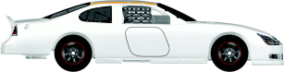

4

5

Time [Sec]

Acceleration:

Distance [m]

0 1 2 3 4 5 6

**Day 3: Forces PPT**

/29

1. What does it take to move the books?
2. What is a force? A force is a ______________________ or a ______________________.
3. Force is what causes things to ______________________________________.
4. What is the formula for Force?
5. What are the units for force?
6. What do they call that unit? ______________________
7. What is mass?
8. What would happen to our rate of acceleration if we added more mass?

[Hypothesis]:

1. Predict what a graph with more mass would look like and draw it on the graph below.

*Draw a different (darker) correct line if your prediction above was incorrect*

(*Create Hypothesis, then* *Go to Forces & Motion Creation Lab*)

Use the following diagrams in the following scenarios

* = keep the same = increase = decrease

If…

*Force = Mass x acceleration *Force = Mass x acceleration

Force = *Mass x acceleration Force = *Mass x acceleration

Force = Mass x *acceleration Force = Mass x *acceleration

1. Properties of Mass:
   1. Mass has inertia. What is inertia?
2. Fill in the blank:
   1. An object in motion will ________________ in _________________________ unless acted upon by another ____________________.
   2. An object at rest will ______________________ at ______________________ unless acted upon by another ____________________.

*If more mass equals more inertia then if I have more mass, I have more inertia. Therefore, if I have more mass, then it should be harder to push or pull (or even start and stop).

1. Which would you rather try to stop: a baseball or a car with your bare hands? Why?

(What does the car have more of?) _______________

**Inertia Demo Video**

/6

Draw arrows depicting what you predict will happen to the following scenarios:

a. Ring & Ball b. Penny & Beaker c. Beaker & Paper

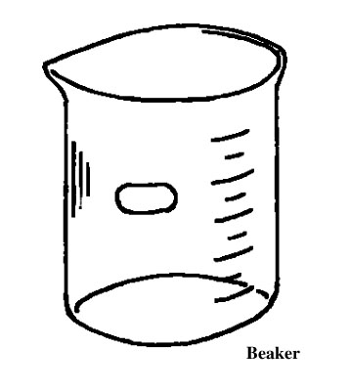



d. Knife & Apple e. Chair & Books f. Egg & Pan

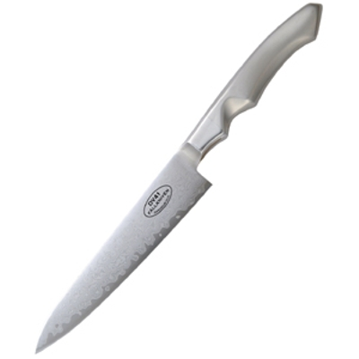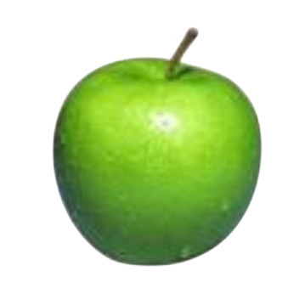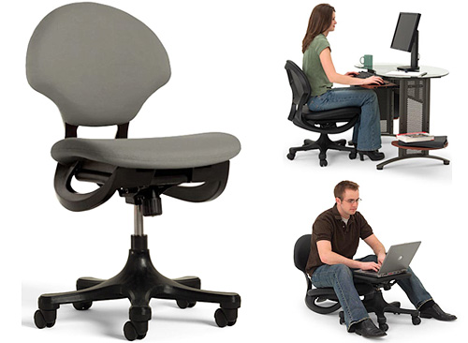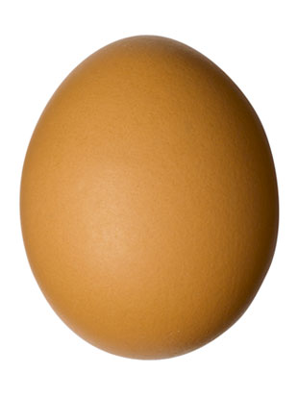

/38

**Question**: What factors make it difficult to move an object?

**Hypothesis:**

**Variables:** From your hypothesis, think of a big lab idea that you could test your hypothesis out on and identify your variables:

|  |  |
| --- | --- |
| **Variables I can change up**  **(Independent)** | **Variables that I can measure as a result of the change (Dependent)** |
|  |  |

Independent (what will you change?) _______________________________________

Dependent (what will you measure in response?) _______________________________________

Control Variables (what will you keep the same?)(2) _______________________________________

_______________________________________

**Question II**: Refine your question: How does ______________________________ {Independent variable}

affect _______________________________________________________________ {Dependent Variable}

**Hypothesis II:** State your hypothesis as an if / then because statement

**Lab Procedures**: How will you carry out your lab? What are your procedures? What materials will you need? (4)

**Data**: (Consider the best way to show your data; line graph, bar graph, pie etc. Next create a data table that best fits the observations you are about to make. Then create a graph to display your results).(10)

**Conclusion**: (10)

* What occurred in the experiment?
* Did your data prove or disprove your hypothesis as being correct?
  + What does this say about your hypothesis?
* Were there any experimental errors along the way
  + How might this have impacted your results?
  + How would you carry this out differently if you were to do this over again?
  + What would you predict the outcome to be if you were to redo it differently?
* Further research or testing
  + What other questions do you have that resulted from your findings?
  + Are there other applications that you can apply your new found knowledge to?
* What did you learn overall?

**Day 4: Unbalanced Forces PPT**

/22

1. For every action there is an _________________________ & ___________________________ Reaction.
2. What do balanced forces cause? _________________________ or _________________________________
3. What do unbalanced forces cause? _________________________________________
4. Draw arrows which best illustrate the concepts below.

Balanced Force Additive Force Subtractive Force

Cause: ______________ Cause: ______________ Cause: ______________

1. What is friction?
2. Is friction an additive force or subtractive force? ________________
3. What happens to a skydiver when he first jumps out of a plane?
4. What eventually happens to a sky diver as he speeds up?
5. What is terminal velocity?
6. Draw the graph of a skydiver undergoing terminal velocity?

/66

**Purpose**: The purpose of this lab is to examine opposing and balancing forces, how friction affects motion and how mass increases inertia.

**Part 1**: Mass & Inertia.

*Q: How does mass influence the amount of force it takes to move an object?*

H:

**Procedures**: Stack 1 book at a time on top of the block and pull the block across the desk.

|  |  |  |  |  |
| --- | --- | --- | --- | --- |
| **Books Used** | **Blocks**  **Mass** | **Books**  **Mass** | **Total**  **Mass** | **Force Required to move it [N]** |
| 0 books |  |  |  | Use the 5N meter |
| 1 Book |  |  |  | Use the 5N meter |
| 2 Books |  |  |  | Use the 10N meter |
| 3 Books |  |  |  | Use the 10N meter |

**Data Analysis:**

1. Was it easier or harder to get the block moving with more mass?
2. What happens to the amount of force required to move the block when we added more books? How does that relate to mass & inertia?
3. With respects to the previous questions, what trend did you notice with the amount of force it took to move the block when you added more mass to the block?

**Conclusion**:

1. Write a short concluding paragraph describing the relationship between mass & inertia and the amount of force needed to move the object.

**Part 2**: Opposing Forces _ Spring to Spring

*Q: Are forces equal?*

H:

**Procedures**: In this part, gently attach your 5N spring meter to another 5N spring meter. Gently tug your spring meter with the other spring meter then read both readings.

|  |  |  |  |
| --- | --- | --- | --- |
| **Pull** | **Trial** | **Spring 1 Force** | **Spring 2 Force** |
| Easy | 1 |  |  |
| Medium | 2 |  |  |
| Hard | 3 |  |  |

**Data Analysis:**

1. What did you notice about your spring in comparison with the other person’s spring? Were your readings the same or different? Why do you think so?
2. Do you think this was a balance of forces or do you think this was an imbalance of forces? Why?
3. Why are these measurements in Newton’s and not grams?

**Part 3**: Subtractive forces of friction

*Q: How does friction play a role in the amount of force it takes to move an object?*

H:

**Procedures**: Use the 5N force meter to pull the block across the different **flat** test surfaces.

|  |  |  |
| --- | --- | --- |
| **Block Mass:** |  |  |
|  |  |  |
| **Surface** | **Texture: How does the surface feel?** | **Force required to move the block** |
| Bare Board |  |  |
| Clear Vinyl |  |  |
| Blue Flannel |  |  |
| Sandpaper |  |  |

**Data Analysis:**

1. Compare and contrast the different surfaces. What explains the difference between these different surfaces?
2. Compare and contrast the required force to move the block. Explain what causes a particular surface to require more force to move an object faster than another.

1. How would you model these differences in surface texture and why it requires different forces to move an object?
2. Explain why a car might experience difficulty steering if the left half of the car is on the road, and the right half is on the grass.

**Conclusion**:

1. According to your data, is your hypothesis correct? How does friction affect the amount of force needed to move an object?

**Part 4:** *Additive Forces*

*Q: What happens when there are two or more forces applied on an object?*

H:

**Procedures**:

Test 1: Take a block of wood w/ the one book & use *one* 5N force meter to drag the block.

Test 2: Take a block of wood w/ the one book and use *two* 5N force meters to drag the block.

|  |  |  |  |
| --- | --- | --- | --- |
| Force w/ one meter |  | Force w/ 2 meters | Force w/ 2 meters |
| Meter Reading |  | Meter 1 Reading | Meter 2 Reading |
|  |  |  |  |

**Data Analysis:**

1. Compare your data, what pattern do you notice concerning using 1 force meter and using 2 force meters?
2. **Apply**: How does this explain the forces acting on a vehicle when 1 person pushes it and when 2 or more people push it?

**Conclusion:**

1. According to your data, is your hypothesis correct? What happens when there are two or more forces applied on the same object??

**Part 5**: Balanced Forces & Terminal Velocity

*Q: How does air (fluid friction) affect falling objects?*

H:

**Procedures**:

**Test 1**: Take a piece of paper and mass it out. Drop it from a meter high. Time it to see how long it takes to fall.

**Test 2**: Take that same piece of paper, crumple it up, mass it out and drop it a meter high. Time it to see how long it takes it to fall.

|  |  |  |
| --- | --- | --- |
| **Paper Shape** | **Mass** | **Time to Drop** |
| **Flat Paper** |  |  |
| **Crumpled Paper** |  |  |

**Data Analysis**:

1. Did the mass of the object change when you crumpled it up? Explain this phenomenon.
2. Did the time the paper took to hit the surface change – explain what may have caused this phenomenon to occur?

**Conclusion:**

1. Using your data, explain how air (fluid friction) affects falling objects. Is your hypothesis in the right direction?
2. How would you model your explanation?

**Part 6:** Balanced Forces

*Q: What does it take to balance out a mass on a lever?*

H:

**Procedures**: Set up the apparatus as illustrated until it’s balanced:

1s slow

1.2m

|  |  |  |  |  |
| --- | --- | --- | --- | --- |
| **Lab Test** | **Mass A** | **Location of mass A [cm]** | **Mass B** | **Location of mass B [cm]** |
| 1 | 200 g | 15 cm | 200 g |  |
| 2 | 200 g | 20 cm | 200 g |  |
| 3 | 200 g | 10 cm | 100 g |  |

**Questions:**

20. From lab test 1, what were the control variables in test 2? ________________________________________

21. From lab test 1, what were the independent variables in test 2? ________________________________________

22. From lab test 1, what were the dependent variables in test 2? ________________________________________

**Data Analysis:**

23. What is the relationship between mass and distance? When you placed a 200g mass @ 15cm from the fulcrum, how far did you have to move the mass on the other side?

24. When you placed a 200g mass @ 10cm, how far did you have to place the mass that was half the original mass?

**Conclusion**:

25. Using your data, answer the original question: “*What is the relationship between mass & the distance it is from the fulcrum?*”

**Balancing out Balances Part II**

**Procedures**: Balance out the following diagrams using the counter balances on the right:

2s slow

2.4m

3s slow

3.6m

2sec

3m

/29

/22

**Data Analysis:**

26. Explain why you placed the masses where they are on each of these diagrams.