**Scientific Method**

**& Lab Skills**

A way of knowing & Learning how nature works.

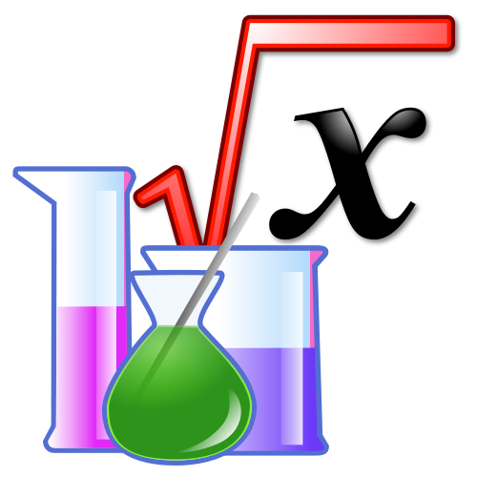

**Mr. Medler Room 106**

www.cmedler.weebly.com

Name: ___________________________________________ Period: ___________

|  |  |
| --- | --- |
| **Lab Activities** | **Score** |
| Starter Questions | 10 points / page |
|  |  |
| Vocabulary |  |
| Day 1: Units of Measurement PPT |  |
| Mass, Length, Volume Lab |  |
| Lab Skills Review (Hw) |  |
| Data Detectives (Hw) |  |
| Day 2: Field Research & Data Analysis Lab |  |
| Day 3: Thinking Like a Scientist PPT |  |
| Facts v. Inference (HW) |  |
| Day 4: Lab Development Basics |  |
| Day 5: Theories & Laws, Black Bottle Inquiry |  |
| Day 6: Informational Texts |  |
| Total: |  |

**Starter Questions:**

|  |
| --- |
| Day 1: Lab Skills  Do vocabulary |
| Day 2: Field Research |
| Day 3: Thinking Like a Scientist |
| Day 4: Lab Development Basics    **/ .** |
| Day 5: Black Bottle – Theories and Laws |
| Day 6: Informational Texts |
| Day 7: Walk away |

**Unit Vocabulary:** (Use a dictionary or science textbook to complete the words below)

**/24**

(On Page 936, find the definition in the paragraph)

1. **Word: Mass**
   1. Definition:_____________________________________________________________________**________________________________________________________________________________**
   2. What instrument would you use to find mass?

**______________________________________________________________________________**

1. **Word: (Liquid) Volume** 
   1. Definition:_____________________________________________________________________________________________________________________________________________________
   2. What instrument would you use to find Volume?

______________________________________________________________________________

*On page 934 find the definitions for the following terms*

1. **Word: Observing**
   1. Definition:_____________________________________________________________________________________________________________________________________________________
2. **Word: Inferring**
   1. Definition:_____________________________________________________________________________________________________________________________________________________
3. **Word: Predicting**
   1. Definition:_____________________________________________________________________________________________________________________________________________________
4. **Word: Classifying**
   1. Definition:_____________________________________________________________________________________________________________________________________________________
5. **Word: Models**
   1. Definition:_____________________________________________________________________________________________________________________________________________________

*(On Page 938, find the definition in the paragraphs)*

1. **Word: Hypothesis**
   1. Definition:_____________________________________________________________________________________________________________________________________________________
2. **Word: Variable**
   1. Definition:_____________________________________________________________________________________________________________________________________________________
3. **Word: Independent Variable**
   1. Definition:_____________________________________________________________________________________________________________________________________________________
4. **Word: Dependent Variable**
   1. Definition:_____________________________________________________________________________________________________________________________________________________
5. **Word: Control Variable**
   1. Definition:_____________________________________________________________________________________________________________________________________________________
6. **Word: Data**
   1. Definition:_____________________________________________________________________________________________________________________________________________________
7. **Word: Conclusion**
   1. Definition:_____________________________________________________________________________________________________________________________________________________
8. **Theory**
   1. Definition:_____________________________________________________________________________________________________________________________________________________
9. **Evidence**
   1. Definition:_____________________________________________________________________________________________________________________________________________________

**Definition Question**

1. What is the difference between inferring, interpreting and assumption, and provide an example for each?

2. What is the difference between investigation and experiment and provide an example for each?

3. What is the difference between a hypothesis and a theory?

**Day 1: Units of Measurement PPT**

**/23**

/3

1. How do you go about collecting data?
2. Decimals or Fractions? ___________________________

Metric System Matrix: /14

|  |  |  |
| --- | --- | --- |
| **Measures**  (Identify & Define Variable) | **Instrument**  (Identify & Draw) | **Unit** |
|  |  |  |
|  |  |  |
|  |  |  |
|  |  |
|  |  |  |

**Metric Conversions (Pre-fixes)**

1. **What are the three main prefixes we use in the metric system?** /6

|  |  |
| --- | --- |
| **Prefix** | **How many main units** |
|  | **= Main Units** |
|  | **= of a Main Unit** |
|  | **= of a Main Unit** |

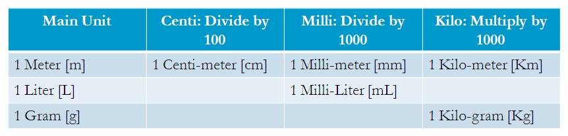

**Mass, Length & Volume Lab**

Overall Score

**/55**

**Mass Lab**

ML /19

**Problem**

What is the proper way to use a triple-beam balance to measure the mass of different objects?



**Materials**

* Triple-beam balance
* 100-mL graduated cylinder
* 3 different small, solid objects

**Procedure**

Before you measure the mass of any object, be sure that the riders on the balance beams are moved all the way to the left and the pointer rests on zero. If necessary, slowly turn the adjustment knob until the pointer rests on zero. This is called zeroing the balance.

**Part 1 Measuring Mass Directly**

1. Find the mass of three random objects of your choice from the front of the room.
2. Zero out the balance.
3. Place the objects on the triple beam balance
4. Find the mass.

**Data Table 1**

/6

|  |  |
| --- | --- |
| **Object** | **Mass [g]** |
|  |  |
|  |  |
|  |  |

**Part 2 Finding Mass by Difference**

1. Find the mass of an empty graduated cylinder. Record the mass in Data Table 2 below.
2. Fill the graduated cylinder with 20 mL of water.
3. Find the mass of the graduated cylinder and water. Record the mass in Data Table 2.
4. Calculate the mass of the water by subtracting the two measurements.
5. Record the calculated mass of the water in Data Table 2.

**Data Table 2**

**/3**

|  |  |  |
| --- | --- | --- |
| **Mass of Empty graduated cylinder (g)** | **Mass of graduated cylinder with 20 mL Water (g)** | **Mass of Water (g)** |
|  |  |  |

**Analyze and Conclude /10**

1. Which rider on the balance should always be moved first when finding the mass of an object? Why?
2. What does it mean when the pointer of the balance reads “zero”?
3. Suppose you did not zero the balance before finding the mass of an object. How might that affect your measurement?
4. In this lab, you found the mass of 20 mL of water. How would you attempt to calculate the mass of 1 mL of water without using the balance?
5. Describe how you could find the mass of a certain quantity of milk that you poured into a drinking glass.

**Length Lab**

LL /21

**Pre-Questions (1pt ea)**

1. What does each unit represent? /15

(a) mm = ________________________ (b) m = ________________________

(c) cm = ________________________ (d) km = ________________________

2. How much does each one equal?

(a) 1 m = _______ cm (b) 1 cm = _______ mm (c) 1 km = _______ m

3. Which measurement is the largest? Circle your answer for each pair.

(a) 14 mm or 1 cm (b) 3.4 cm or 30 mm (c) 1 m or 990 cm (d) 85 cm or .86 m

4. Circle the BEST metric unit for each.

(a) The length of an eyelash: mm cm m km

(b) The height of a flagpole: mm cm m km

(c) The length of a strand of spaghetti: mm cm m km

(d) The distance from Chicago, IL, to Peoria, IL.: mm cm m km

**Data Collection (DON’T FORGET YOUR UNITS!) /6**

5. Use a meter stick to find each measurement.

(a) Length of the table in meters ________ _____

(b) Width of the table in centimeters ________ _____

(c) Height of the table in millimeters ________ _____

**Volume Lab**

VL /15

**Data Collection Part A: Volume by Formula**

Use the formula to find the volume of the block. Measure to the nearest centimeter before calculating your answer. INCLUDE YOUR UNITS!

**/4**

**Length x Width x Height = Volume**

Measure the block on the plate.

**_________ x _________ x _________ = __________**

**Data Collection Part B: Water Displacement**

Follow the directions to find the volume of the marble using water displacement.

(1) Add 20 ml of water to a 100 ml graduated cylinder. Record this amount in the chart.

(2) Add the marbles to the cylinder and measure the new volume. Record this amount in the chart.

(3) Find the difference between the two measurements and record in the chart. The difference between the two measurements will be the volume of the marble.

**/4**

|  |  |  |  |
| --- | --- | --- | --- |
| **Volume of water before adding marble** | **Volume of water after adding 1 marble** | **Difference in volume** | **Calculate the Volume of 3 marbles** |
|  |  |  |  |

**Part C: Count your drops! /7**

*Take a guess - How many drops of water will it take to equal 1 milliliter? __________ drops*

Follow the directions to find the number of drops in 1 milliliter of water, then answer the questions. You will need a small graduated cylinder (25 ml), a beaker of water, and an eyedropper for this section.

(1) Fill a small graduated cylinder with 10 ml of water.

(2) Count the number of drops it takes to raise the water to 11 ml. Record the number in the chart.

(3) Leave the water in the graduated cylinder and count the number of drops it takes to raise the water to 12 ml. Record the number in the chart. Repeat to 13 mL.

(5) Calculate your average and round to the nearest tenth.

|  |  |  |  |
| --- | --- | --- | --- |
| **#drops: 10 to 11 mL** | **#drops: 11 to 12 mL** | **#drops: 12 to 13 mL** | **Average** |
|  |  |  |  |

Based on your average, how close were you to your guess? ____________

Based on your average, how many drops would it take to make 1 liter? _________

**Lab Skills Review (Hw)**

/15

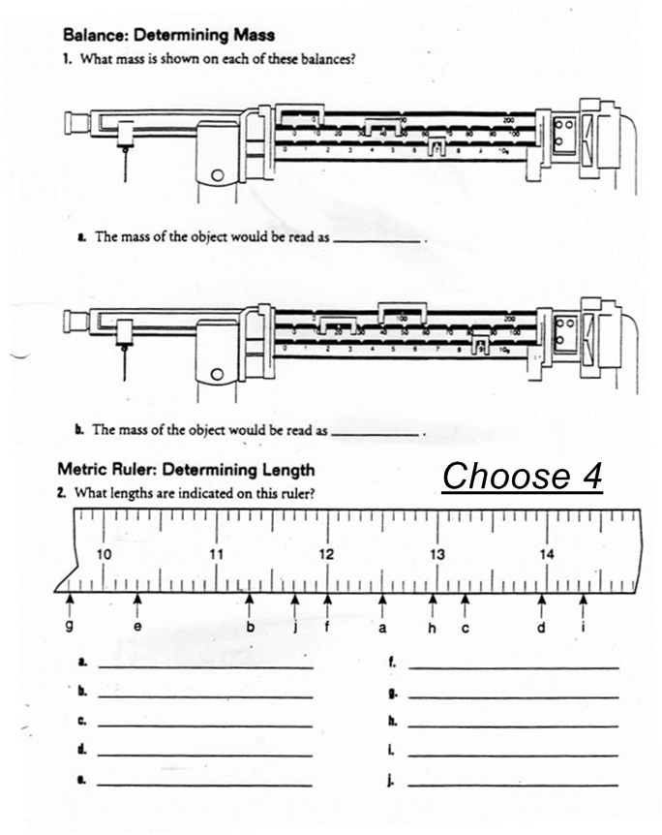

Choose 4

Choose 5

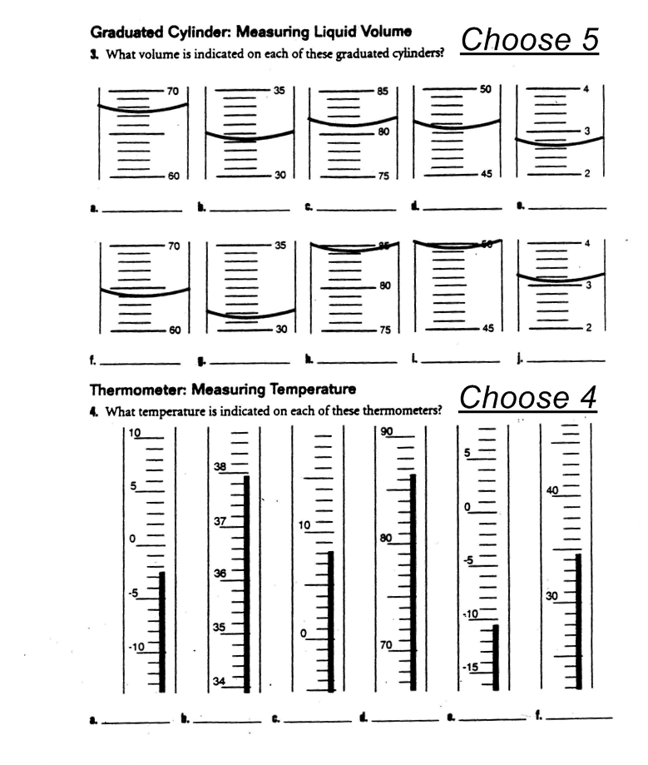

*Data Detectives*

**/14**

**Graph Activity 1: Plotting Points – Velocity Lab**

Below are the data several scientists collected from a running experiment. Please follow the procedural instructions for the graph provided below.

*Procedures:*

1. Give your graph a title
2. Using the variables, label the x & y axis (*Hint: Time is traditionally on the x axis*).
3. Create a scale for both your axes.
4. Plot each of the points listed from the experiment found under the data table.
5. Connect your data points.
6. Answer the following questions:

/12



*Questions:* /2

1. Between what two points was the runner not moving? ___________________
2. Between what two points was the runner going the fastest? _____________________

**Day 2: Field Research & Data Analysis**

/20

On a blank page, collect & record as much data as you can find in the hallway. Next, organize/ categorize your data that makes sense to you. Next, interpret your data: what does it all mean? What makes the best sense of the data you collected? What do you think is going on? Put it together in a way that makes sense to you. In other words, what do you think it all means? Be prepared to present your understandings & findings to the class.

On this page, write me a paragraph and tell me what you learned from having done this activity.

**Day 3: Thinking like a Scientist PPT**

/10

**Six Principles of Science**

**Fill in the blanks:**

**/10**

1. **Science is a way of ________________________________ about the natural world.**
2. **Science is used by __________________________________, not just scientists.**
3. **There are many different ways to ______________________________ the same problem.**
4. **Theories ______________________________________________ in light of new evidence.**
5. **Be willing to test any claim. ______________________________! Don’t just blindly accept what others tell you.**
6. **We assume that scientific principles work the same _______________________ as they have throughout time.**

|  |
| --- |
| Quantitative |
| Qualitative |

**Vocabulary**: Fill in the definitions for each word as we discuss each.

(Don’t forget the vocabulary at the beginning of the packet.)

**Observing:** Using one or more of your _________________________ or ___________________________to gather information.

Facts vs. Inferences

**Introduction**

/26

Scientists are constantly trying to separate truth from fiction. In order to do this, we have to carefully observe the world around us. Through careful observation, you will be able to figure out any problem put before you. The trick is separating facts from simple guesses.

Which of the statements below are factual observations, and which are inferences? Underline the facts in the paragraph below and circle the inferences.

**/10**

“Imagine that you are a homicide detective and that you have just arrived on the scene of a murder. As you walk to the front door of the house you notice that the rain outside has finally stopped. The front door is locked. You pry open the door and go in. Mrs. Williams is lying in bed. She is dead. The bedroom window faces a neatly kept garden. The window is open and there are several small puddles of water between Mrs. William’s bed and the window. The woman is wearing a pearl necklace and there is a bottle of pills on the night table near the bed. Mr. Williams is out of town on business when you try to phone him.

Later that day you tell your boss that because Mrs. Williams was still wearing her pearls, robbery could not have been the motive. It was obviously a case of murder. The murderer must have come in through the bedroom window and killed Mrs. Williams. The puddles of water were left by the murderer’s shoes.”

**Fact**: Something that is actually observed.

**Inference**: A conclusion or an opinion that follows logically from something observed.

**Even More Inferences**

Answer the questions listed below. Most questions can be solved by using outside knowledge and clues from the text to make an inference. *(2pts each)*

1. James licked the final square, posted it at the top corner of the envelope and dropped it in the large blue box. He hoped it would get there in time. Nobody likes a late birthday message.
   1. What was James doing? ____________________________________________________
2. I just can’t figure them out. Sometimes I get so frustrated. Like when I ask the file to save, and I come back and hour later and it has erased my paper. Those are the things that just irritate me. I also can’t stand all these goofy names, ‘mouse’, ‘web surfing’, who ever made up such nonsense.
   1. What is frustrating the man? _______________________________________________
3. Maurice loved the feeling of being launched at such fast speeds. He looked forward to the twists and turns, and the upside down loops. The park had gotten so expensive that his family could only afford to go once a year, so Maurice would count down the days until he could feel his hair blowing in the wind as he raced around the track.
   1. Where does Maurice’s family go once a year? __________________________________
4. Of all the chores Tavon had around the house, it was his least favorite. Folding the laundry was fine, doing the dishes, that was alright. But he couldn’t stand hauling the large bags over to the giant sliver canisters. He hated the smell and the possibility of rats. It was disgusting.
   1. What chore does Tavon hate? ______________________________________________
5. The campers sat at the campfire, laughing and having a good time when a strange noise came from the woods. The campers suddenly became silent and sat very still as they could hear a rustling in the bushes. They had heard that bears were known to have lived around this area and therefore began to panic. Suddenly, the creature appeared from the bushes. It was hardly a bear. In fact the large whiskers, twitching nose, and floppy ears couldn’t have scared anyone.
   1. What is the animal that visits the camp? ______________________________________
6. He gave a speech in front of a boisterous crowd. Flags were perched all along the pulpit and he talk about what could be done to improve the lives of everyday Americans. Only a few months later he would be sworn into office, promising to work hard to lead America.
   1. Who is this person giving the speech? ________________________________________
7. He loved all the characters. That was the best part of the show. Homer, Marge, Bart, they all made him laugh. It was nice to sit down, smile, and not worry about a thing after a long day of working.
   1. What show does this person watch to relax? ___________________________________
8. “To be or not to be, that is the question,” he would recite those famous works from his favorite playwright. He loved Hamlet, and Mac Beth, but his favorite, well his favorite had to be A Midsummer Night’s Dream.
   1. Who was this person’s favorite playwright? ____________________________________

Day 4: Lab Development Basics:

/49

|  |  |  |
| --- | --- | --- |
| Observations | Background Knowledge | 2 Questions |
| /10 | /5 | /4  1 Answer /2 |

|  |  |
| --- | --- |
| **Variables**  **/10** | **Test Question:**  **/6**  How does ____________________________ affect ___________________________________?  **Test Statement & Hypothesis:**  If I change _________________________________ then _______________________________ should happen as a result because… |
| **Procedures:**  /4 |
| **Observations**: *(You can use the graph on the following page if necessary)*  /4 |
| **Conclusion**:  /4 | |

**GRAPHING RESULTS**

*What I measured or observed*

*(Dependent Variable)*

*What I changed*

*(Independent Variable)*

**X Axis** *(Note: Both axes will need to be labeled and the appropriate scale marked)*

**Y**

**Axis**

Title of Graph: ___________________________________

|  |  |  |  |  |  |  |  |  |  |  |  |  |  |  |  |  |  |  |  |  |  |  |  |  |  |  |  |  |  |  |  |  |  |  |  |  |  |  |  |
| --- | --- | --- | --- | --- | --- | --- | --- | --- | --- | --- | --- | --- | --- | --- | --- | --- | --- | --- | --- | --- | --- | --- | --- | --- | --- | --- | --- | --- | --- | --- | --- | --- | --- | --- | --- | --- | --- | --- | --- |
|  |  |  |  |  |  |  |  |  |  |  |  |  |  |  |  |  |  |  |  |  |  |  |  |  |  |  |  |  |  |  |  |  |  |  |  |  |  |  |  |
|  |  |  |  |  |  |  |  |  |  |  |  |  |  |  |  |  |  |  |  |  |  |  |  |  |  |  |  |  |  |  |  |  |  |  |  |  |  |  |  |
|  |  |  |  |  |  |  |  |  |  |  |  |  |  |  |  |  |  |  |  |  |  |  |  |  |  |  |  |  |  |  |  |  |  |  |  |  |  |  |  |
|  |  |  |  |  |  |  |  |  |  |  |  |  |  |  |  |  |  |  |  |  |  |  |  |  |  |  |  |  |  |  |  |  |  |  |  |  |  |  |  |
|  |  |  |  |  |  |  |  |  |  |  |  |  |  |  |  |  |  |  |  |  |  |  |  |  |  |  |  |  |  |  |  |  |  |  |  |  |  |  |  |
|  |  |  |  |  |  |  |  |  |  |  |  |  |  |  |  |  |  |  |  |  |  |  |  |  |  |  |  |  |  |  |  |  |  |  |  |  |  |  |  |
|  |  |  |  |  |  |  |  |  |  |  |  |  |  |  |  |  |  |  |  |  |  |  |  |  |  |  |  |  |  |  |  |  |  |  |  |  |  |  |  |
|  |  |  |  |  |  |  |  |  |  |  |  |  |  |  |  |  |  |  |  |  |  |  |  |  |  |  |  |  |  |  |  |  |  |  |  |  |  |  |  |
|  |  |  |  |  |  |  |  |  |  |  |  |  |  |  |  |  |  |  |  |  |  |  |  |  |  |  |  |  |  |  |  |  |  |  |  |  |  |  |  |
|  |  |  |  |  |  |  |  |  |  |  |  |  |  |  |  |  |  |  |  |  |  |  |  |  |  |  |  |  |  |  |  |  |  |  |  |  |  |  |  |
|  |  |  |  |  |  |  |  |  |  |  |  |  |  |  |  |  |  |  |  |  |  |  |  |  |  |  |  |  |  |  |  |  |  |  |  |  |  |  |  |
|  |  |  |  |  |  |  |  |  |  |  |  |  |  |  |  |  |  |  |  |  |  |  |  |  |  |  |  |  |  |  |  |  |  |  |  |  |  |  |  |
|  |  |  |  |  |  |  |  |  |  |  |  |  |  |  |  |  |  |  |  |  |  |  |  |  |  |  |  |  |  |  |  |  |  |  |  |  |  |  |  |
|  |  |  |  |  |  |  |  |  |  |  |  |  |  |  |  |  |  |  |  |  |  |  |  |  |  |  |  |  |  |  |  |  |  |  |  |  |  |  |  |
|  |  |  |  |  |  |  |  |  |  |  |  |  |  |  |  |  |  |  |  |  |  |  |  |  |  |  |  |  |  |  |  |  |  |  |  |  |  |  |  |
|  |  |  |  |  |  |  |  |  |  |  |  |  |  |  |  |  |  |  |  |  |  |  |  |  |  |  |  |  |  |  |  |  |  |  |  |  |  |  |  |
|  |  |  |  |  |  |  |  |  |  |  |  |  |  |  |  |  |  |  |  |  |  |  |  |  |  |  |  |  |  |  |  |  |  |  |  |  |  |  |  |
|  |  |  |  |  |  |  |  |  |  |  |  |  |  |  |  |  |  |  |  |  |  |  |  |  |  |  |  |  |  |  |  |  |  |  |  |  |  |  |  |
|  |  |  |  |  |  |  |  |  |  |  |  |  |  |  |  |  |  |  |  |  |  |  |  |  |  |  |  |  |  |  |  |  |  |  |  |  |  |  |  |
|  |  |  |  |  |  |  |  |  |  |  |  |  |  |  |  |  |  |  |  |  |  |  |  |  |  |  |  |  |  |  |  |  |  |  |  |  |  |  |  |
|  |  |  |  |  |  |  |  |  |  |  |  |  |  |  |  |  |  |  |  |  |  |  |  |  |  |  |  |  |  |  |  |  |  |  |  |  |  |  |  |

Day 5: Laws & Theories

/62

Black Bottle Inquiry

Watch your teacher and record observations with the black bottle. Your teacher will repeat the same demonstration several times. Your job is to record as many different observations as possible using as many of your senses as possible. After ten times, use the observations just recorded and make an inference about the inside of the bottle to explain what you have just observed. Then draw your inference in the bottle illustrated below. You may use words also to describe your drawing on what is inside the bottle.

/22 **Model of Theory:**



/8

|  |  |  |
| --- | --- | --- |
| **Test (9)** | **Observation (9)** | **Inference (4)**  **(what does it mean?)** |
|  |  |  |
|  |  |  |
|  |  |  |
|  |  |  |
|  |  |  |
|  |  |  |
|  |  |  |
|  |  |  |
|  |  |  |

You will be doing something similar as the first time. This time you will be allowed to ask the teacher to try different things to the bottle and each time you will record your observations. After the teachers has tried as many student request as possible. You will use your observations again to come up with an inference to explain the different observations. You will then draw on the bottle picture your idea and inference on how the bottle is designed on the inside.

**Model of Theory:**

 /22

/8

|  |  |  |
| --- | --- | --- |
| **Test (9)** | **Observation (9)** | **Inference (4)** |
|  |  |  |
|  |  |  |
|  |  |  |
|  |  |  |
|  |  |  |
|  |  |  |
|  |  |  |
|  |  |  |
|  |  |  |

Question: /2

1. What happened to your theory of how the bottle worked in light of new evidence?

Review

* Observations – to see
  + the process of collecting evidence.
* Evidence / Facts – *what* you see.
* Inference – **interpreting** *what* you see.
* Predict – **forecasting** based on *what* you see.

Scientific Theories & Laws

* Knowledge in science is built up cautiously.
* Scientists do not accept a new hypothesis after just one successful experiment – but is rather repeatedly tested.
  + Skepticism

Principles you learned from the Black Bottle:

* You collected evidence from the tests you ran.
* You inferred how it works after each test.
* In the end, You created a theory of how it works.
  + An explanation for the large body of evidence you collected.
* You created a model of how it works.
  + Drawing
* You predicted outcomes – and you were surprised if it didn’t meet your expectations.

Your theory changed in light of new evidence.

* **Science is a way of knowing that is used by many people – NOT JUST SCIENTISTS!**
* **There’s no one single way to run a test to find your answers – There are many ways to find your answers!**

Scientific Theory

* A well tested explanation for a wide ray of observations of experimental results.
  + Science accepts a theory only when there is a large body of evidence to support it.

**Theory: The Single Explanation**

* After multiple tests and strong collected evidence, it is the major explanation that explains all of the phenomena we observe. It is sometimes used to help predict any future outcome.

**Theory**

Of Plate Tectonics

**Chapter 1: Volcanoes.**

Observations, Hypotheses, Tests, Evidences, Conclusions

**Chapter 2: Earthquakes.**

Observations, Hypotheses, Tests, Evidences, Conclusions

**Chapter 3: Fossil Evidence.**

Observations, Hypotheses, Tests, Evidences, Conclusions

**Chapter 4: Sea Floor Spread**

Observations, Hypotheses, Tests, Evidences, Conclusions

**Chapter 5: Interior of the Earth**

Observations, Hypotheses, Tests, Evidences, Conclusions

**Theories are EVER CHANGING & EVOLVING**

* **If future testing proves a current theory to be incorrect, scientists modify the theory or discard the theory all together.**

A Theory is **NOT**…

* A Theory is not just a simple idea that someone thought up one morning as they got out of bed.
  + It is based on a careful and rational examination of the facts
    - It has a large body of evidence.
  + It is based on observation, experimentation, and reasoning.
    - It is tested over and over again.
  + It is a model which helps us to predict natural phenomena.
  + It is peer reviewed.

Different Theories:

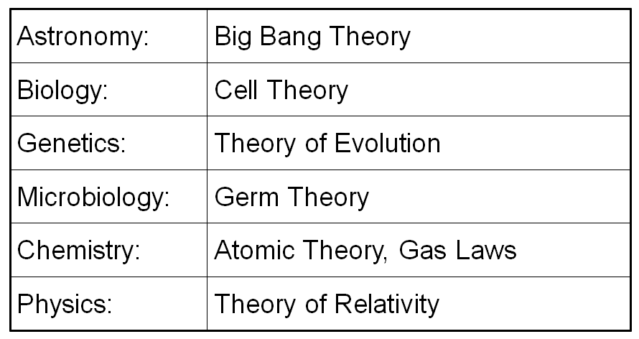

Scientific Law

* A statement that describes what scientists expect to happen ***every time*** under particular set of conditions.
  + Basically considered “scientific fact”
    - A rule of nature:
      * Gravity: What comes up, must come down.
      * (All objects in the universe attract each other)

**Think about it:** What if we found a planet where gravity worked in reverse? What would happen to the “Law of Gravity?”

Natural Laws

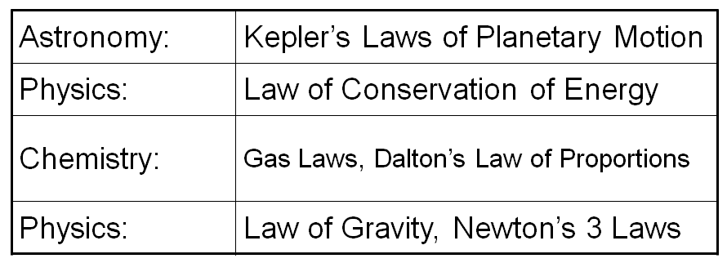

Day 6: Research Basics – an introduction to the personal research project

Scientific Reading:

* Discuss how to further your research
* Discuss what makes a credible source
  + Books & text books
  + Articles
    - Newspapers
    - Magazines
  + Internet
* (If you feel up to it - discuss bias and what it looks like)
* Identify the following in a text book & how to use them
  + Table of contents
  + Headers & sub headers
  + body
  + Glossary
  + Index
* Identify the following in an article (Circle)
  + Introduction *(Thoughts leading up to the question)*
  + Question (Q in Margin)
    - The scientist is one who asks the right questions
  + Thesis (T in Margin)
  + Claims and assertions
  + Keywords (Circle)
  + Variables (Square)
  + Graphs & other visuals (*)
  + Conclusion (C in Margin)
  + Sources (Circle section – put an “S” in the margin)
* How to use the internet as a source
  + Google scholar
* Introduce the “personal research project”

Reading Informational Texts

/30

/20

* Identify the following in the article below
  + Title (Underline and put the word “Title” by it)
  + Author (Circle and put the word “Author” by it)
  + Date the article was published (Circle it and put a “D” by it)
  + Source of the article (Circle it and put the word “source” by it)
  + Introduction (Bracket the paragraph and put the word “Intro” in the margin)
    - [These are the thoughts leading up to the question]
  + Essential Question (Underline and put a “Question” in the Margin)
    - [This is the question that drives the research]
  + Thesis (Underline and put a “Thesis” in Margin)
    - [This is the claim or statement]
  + Claims and assertions (underline and put “A” in the margin)
    - [Claims or statements that support the thesis]
  + Procedures (bracket the section and write “procedure” in the margin)
    - [Procedures are the step by step process of how they carried out their experiment]
  + Keywords (Circle)
    - [These are words that are important to know & essential to understand]
  + Variables (Square)
    - [These are the things that *can* change in an experiment]
  + Graphs & other essential visuals (Circle & “*” in the margin)
  + Conclusion (Bracket and put the word “conclusion” in the margin)
    - [This is the summary, and usually restates the question and basic overview of the findings]
  + Sources (Circle it and put the word “sources” in the margin)
    - [This is where the author got his information]

Discussion:

/10

1. Where all of parts of the essay found in the article – if not which ones were missing?
2. What were the controlled variables in this experiment?
3. What were the independent variables in this experiment?
4. What were the dependent variables in this experiment?
5. What was the result of their findings?

# 

*HW: Do this same thing with a science related article at home.

(Additional 30 points)Nature resets body’s clock

By Meghan Rosen / August 6, 2013

[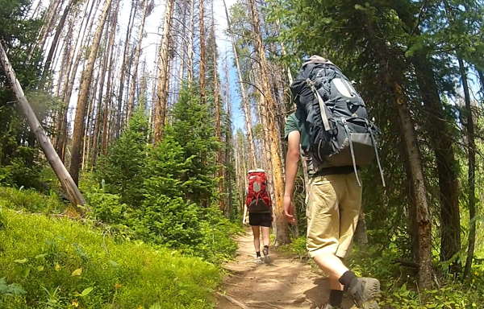](http://www.sciencenewsforkids.org/wp-content/uploads/2013/08/CAMPING_RESETS_CLOCK.j)

After a week spent in the Colorado woods, campers fell asleep earlier and woke up earlier. Their internal clocks shifted, syncing up with sun. Credit: Courtesy of K. Wright Jr.

A short camping trip could help people rise and shine, researchers report. After a week living in tents in Colorado’s Rockies, campers’ internal clocks shifted about two hours earlier. It transformed even night owls into early birds.

“It’s a clever study, and it makes a dramatic point,” says Katherine Sharkey. A sleep researcher and physician at Brown University in Providence, R.I., she did not work on the new study. People get much more light outside than they do indoors, she notes. And that can reset their [internal body clocks](http://www.sciencenewsforkids.org/2013/07/respecting-the-bodys-clocks/).

A master clock in the brain controls the release of melatonin. This hormone prepares the body for sleep. Melatonin levels rise in the early evening and then taper off in the morning before a person wakes up.

But many people today spend their days indoors and their nights bathed in the glow of electric lights (including the light emitted by TVs and computers). Too little early morning light and too much evening lighting can throw the body’s clock out of sync. This unnatural lighting can trigger the body to ramp up melatonin levels later at night. It can also lead the hormone levels to fall later than normal in the morning — often after a person has woken up. Lingering levels of this sleep hormone can make people groggy.

Kenneth Wright Jr., a sleep researcher at the University of Colorado, Boulder, and colleagues whisked eight volunteers away for a summer camping trip. After nightfall, the campers used only campfires for lighting. No flashlights (or cellphones) allowed.

Each day, the campers soaked up four times as much light as they got indoors. They also went to sleep and naturally woke up more than an hour earlier than they had before the trip.

Tests done after the volunteers got home again showed that their melatonin levels now climbed around sunset. They also petered out at sunrise — two hours earlier than before they had gone camping. Wright’s team published its findings August 1 in Current Biology.

People might not even need to rough it to nudge their internal clocks back. Typical office and school lighting is less than one percent as bright as a midsummer day. So even brief stints outside might help. This would be especially true if people encountered outdoor light early in the morning. That’s when the body’s clock is most susceptible to resetting.

“Start your day off with a morning walk, and open the [window] shades to expose yourself to sunlight,” Wright advises.

**Power Words**

**body clock (also known as biological clock)**A mechanism present in all life forms that controls when various functions such as metabolic signals, sleep cycles or photosynthesis should occur.

**circadian rhythm**Biological functions such as body temperature and sleeping/waking times that operate on a roughly 24-hour cycle.

**hormone**A chemical produced in a gland and then carried in the bloodstream to another part of the body. Hormones control many important body activities, such as growth. Hormones act by triggering or regulating chemical reactions in the body.

**melatonin**A hormone secreted in the evening by a structure in the brain. Melatonin tells the body that it is nearing time to sleep. It plays a key role in regulating circadian rhythms.

**sync (short for synchrony)** Work together in harmony at the same time or rate, like in a marching band.

https://s2.googleusercontent.com/s2/favicons?domain=www.sciencenewsforkids.org**sciencenewsforkids.org**<http://www.sciencenewsforkids.org/2013/08/nature-resets-bodys-clock/>