Crayfish Dissection Quiz

- Name the following external parts of the crayfish.

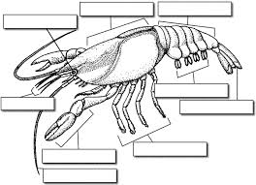

- Name the following Internal parts of the crayfish.

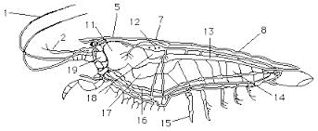
1.
2.
7.
8.
11.
12.
15.

